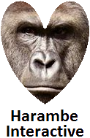

Duck-U-Up

Version V1.4

All work Copyright © 2016 by Harambe Interactive.

All rights reserved.

**Alexander Sikalevski**

Contents

Version History 3

Game Overview 3

Game Play Mechanics 3

Camera 3

Controls 3

Saving and loading 3

Interface Sketch 4

Menu and Screen Description 4

Characters 5

Non-player Characters 5

Enemies 5

Weapons 5

Items 5

Abilities 5

Vehicles 6

Script 6

Scoring 6

Sound Index 6

Story Index 6

Art / Multimedia Index 7

Design Notes 7

Future Features 8

# Version History

V1.0 – Created Basic Game

V1.1 – Added player movement and shooting

V1.2 – Updated hitboxes and enemy sprites

V1.3 - Updated Sounds, User Interface, enemy spawns, and explosions

# Game Overview

Duck-U-Up is a twin-stick shooter. The player controls the duck which can shoot laser beams to destroy the enemy the red circles the universe most powerful enemies.

# Game Play Mechanics

With the wasd and arrow keys the player can move in any direction. If the player left clicks on the mouse or presses the spacebar the duck ship will shoot.

# Camera

The camera will be scrolling from left to right and the player must stay in the cameras pov or else the player will be destroyed.

# Controls

The player can move the duck sprite using the W, A, S, and D keys to move in their respected directions. The player can also move using the arrow keys to move in their respected directions too. The player can use the mouse to aim the duck in a specific direction with precision. Finally the player can left click or press the space bar to shoot lasers in the direction the duck is facing.

# Saving and loading

There will be no saving and loading options.

# Interface Sketch

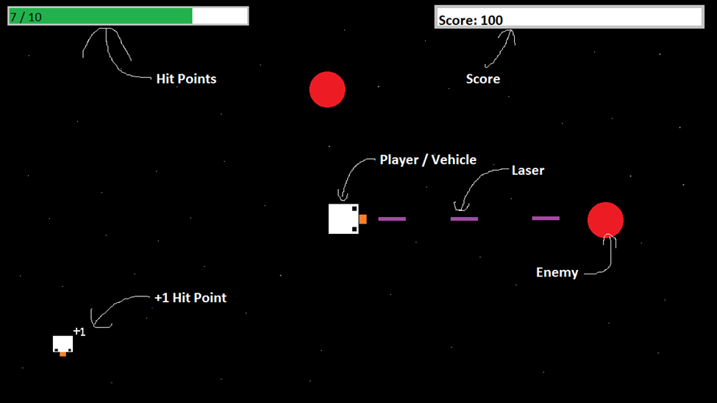

# Menu and Screen Description

Start Screen:

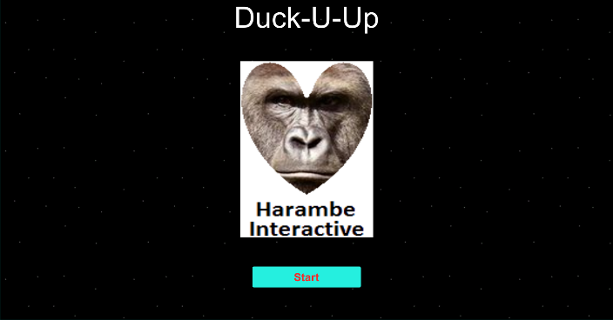

Game Screen:

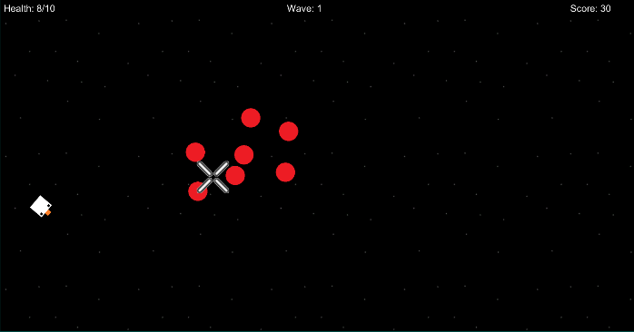

Game Over Screen:

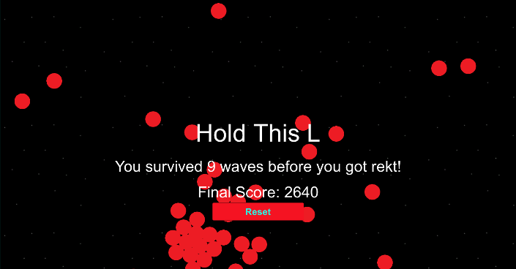

# Characters

The player’s avatar is a duck.



# Non-player Characters

There are no non-player Characters

# Enemies

The main enemy in the game will be the red circles.



# Weapons

The players’ weapon will be the laser beam.  


# Items

The player can pick up the +1 duck power up which will give them +1 hp in game. If the player is at max hp the power up will not do anything.



# Abilities

There are no special abilities just a basic twin-stick shooter.

# Vehicles

There are 2 vehicles in the game the player vehicle and the enemy vehicle.

# Script

[Game Script Assets](https://github.com/im-Alexander/Assignment1_Twin-stick-shooter/tree/master/Assets/_Scripts)

# Scoring

If the player destroys an enemy the player gains +10 points.

# Sound Index



# Story Index

There is no story. Just a duck in outer space.

# Art / Multimedia Index



# Design Notes

There are no design notes.

# Future Features

Implement the following:

* Camera moving side to side with the player
* Invisible wall when touching the top or bottom of the screen
* Increasing enemy difficulty on higher waves
* Random spawning of the +1hp power up